Exercise 1: Implementing the Singleton Pattern
Objective
Implement the Singleton Design Pattern to ensure that only one instance of the Logger class is created and used throughout the application lifecycle.
Files Created
- Logger.java
- SingletonTest.java
Logger.java
public class Logger {
private static Logger instance;
private Logger() {
System.out.println("Logger instance created.");
}
public static Logger getInstance() {
if (instance == null) {
instance = new Logger();
}
return instance;
}
public void log(String message) {
System.out.println("LOG: " + message);
}
}
SingletonTest.java
public class SingletonTest {
public static void main(String[] args) {

Logger logger1 = Logger.getInstance();
Logger logger2 = Logger.getInstance();

logger1.log("First message");
logger2.log("Second message");

if (logger1 == logger2) {
System.out.println("Only one Logger instance exists.");
} else {
System.out.println("Multiple Logger instances exist.");
}
}
}
Output
Application started
Singleton pattern implemented successfully
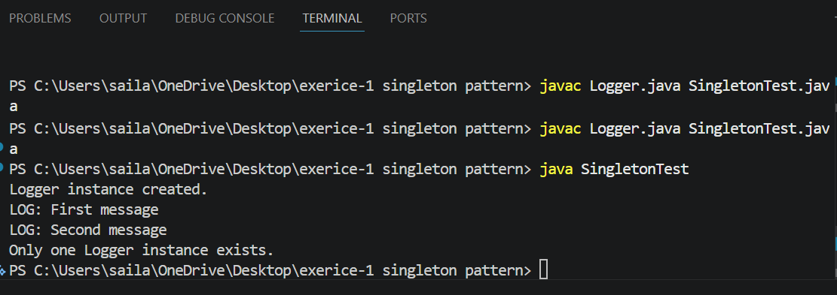
Conclusion
The Singleton Design Pattern was successfully implemented. The Logger class ensures that only one instance is created and shared throughout the application.

